Flow chart of (simple) inventory system

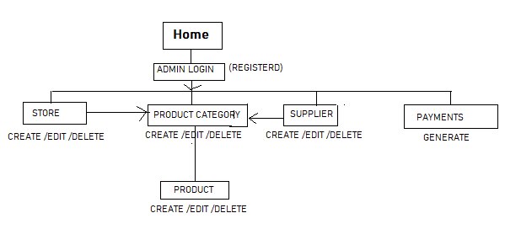

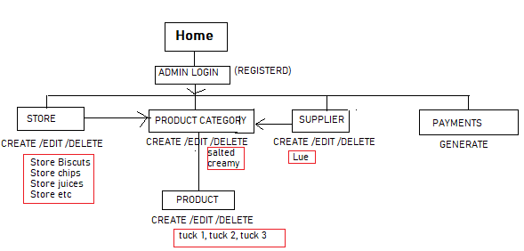

Interview Questions to the client about software development

Building a product inspired by a personal experience and online research without the continuous involvement of the customer is a common approach for creating products that either solve the wrong problem or introduce a solution people aren’t interested in using.

Customer interviews are essential for many reasons. Most importantly, customer interviews are responsible for guiding today’s best products. customer interviews are a great opportunity to build trust and accomplish those goals.

Second, building a personal relationship with your potential buyers minimizes conversion friction later when the product is ready to go to market. People are more likely to work with those they know and trust.

1. Tell me a little about yourself and background? Ask to follow up questions as needed.
2. Describe the problem.

What does your company or organization hope to improve? Outline the problem your company is facing, including the particular pain points you encounter and areas where there is room for improvement or growth. Next, think about where you want your company to go and the steps needed to get you there. Having a thorough understanding of the problem will help you see which vendors are suggesting a feasible solution.

1. Describe your goal

What are your goals for the project, and do they align with the goals of your company? The goals your company hopes to achieve shouldn't contradict or interfere with the overall goals or mission of your company. Before you begin putting together an RFP, make sure the objectives of the project are in line with your business' overall objectives.

1. How are you currently solving this problem?
2. How much time and money have you spent solving or trying to solve this problem?
3. If you built your own perfect solution, what’s the most important functionality you’d have?
4. Post a minimal and complete example demonstrating the problem as well as goal.
5. What are requirements
   1. Technical
      1. Which application do you want?(desktop or web based)
      2. Which language do you prefer?
      3. How will be the user interface?
      4. What will be the flow of information?
      5. What should be the properties and behavior of the system?
   2. Non-technical
      1. Performance (submit and extract information very quickly)
      2. Scalability (should be accessible)
      3. Availability
      4. Reliability (consistent database)
      5. Recoverability (if a module crashed due to some reason should be rolled back partial transaction)
      6. Maintainability (addition of module)

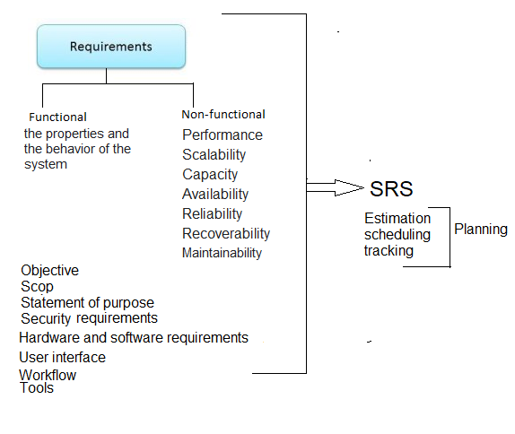

1. What are the target users?
2. What is the scope of the project?

To create an accurate project budget or schedule you need to identify 100% of the project scope. Risk Management will depend on the clarity of the scope of work. Quality Management is simply a part of the scope.

1. Does the new solution integrate with existing systems?

Vendors need to know if they are working on a standalone solution, or if your company plans on working the solution into existing software or other existing programs or protocols. Take time to outline what systems, if any, the solution will work with and how they will play together. It's also a good idea to provide full details on existing systems, such as how they get maintained and updated.

1. What is your budget?

Figuring out your company's budget for the project means more than examining how much money you have to spend. It also means researching market rates and finding out what similar companies have paid for similar projects. You can also contact vendors to find out what they typically charge for projects similar to yours. Setting a budget also gives your vendors an idea of what you're looking for and can help them shape their proposals to your needs.

1. What is your timeline?

You want to give vendors a due date for the proposal and any other material submissions. You also want to give vendors a "know-by" date, or a date by which you expect to make your decision.

It's also a good idea to include a timeline for the project itself. For example, when do you expect the project to go live, and when would you like to receive certain parts or components of the project? Giving vendors an idea of what you expect during the implementation of the project will allow them to confirm they have the bandwidth and ability to work with you.

1. When do you want to start?
2. Who will deployed?
3. Who is the point person on the project?

Vendors are likely to have questions about the RFP, and it's important for your company to designate who is in charge of responding to any questions that come up. It's a good idea to choose a person who has expertise on the subject to serve as the point of contact. It's also smart to tap into anyone on your team who could provide additional information and expert advice as needed. Be sure your point person knows whom they can turn to for answers to specific questions that might come up during the process.

1. Who is decision maker?
2. Who is approved person?
3. What do and don’t you need?
4. What is potential for updates?
5. Can you engage throughout the journey to make process successful?
6. What is your project management style?

